State Budget of Kyrgyz Republic

National Economy

By: Asanbai uulu Nurbek,

Abdykadyrova Ajara

***Content:***

1. ***Introduction***
2. ***State budget and its role***
3. ***State budget’s revenue***
4. ***State budget’s expenditure***
5. ***Proficit and deficit of state budget***
6. ***Government debt***
7. ***Budget transparency***
8. ***Conclusion***
9. ***Literature review***
10. ***Appendix***

***Introduction***

State budget is an important part in governing and regulating economic and social policies. Being a part of government system state budget affects the interests of every citizen. Right management of state budget is a base of stable economic growth. State budget is a planning of government revenue and expenditure over one year period. Each country chooses its own way of management and strategy of realization.

In case of Kyrgyzstan, there are several participants of management of state budget. President of Kyrgyz Republic defines the main directions of state budget policy, setting priority in the budget system. The government is responsible for formulating and implementation of state budget. Ministry of Finance formulates the income and expenditure parts of the project. Jogorku Kenesh considers the budget and adopts the law on state budget. Budget institutions such as Ministry of Education, Ministry of Healthcare and others participate in expenditure part and are responsible for final report. Audit chamber is responsible for controlling and right implementation of the state budget. And of course, the citizens of the country are participants of state budget regulation as they elect the government representatives.

***State budget and its role***

State budget plays an important role in stability of economic and social life of the country. The government achieves the main three purposes through implementation of state budget. First of all, state budget is a provision of public goods and services, such as education, medical healthcare, national defense and others. With help of state budget, government distributes the income equally. So it means that the government takes care of disabled, retired and other people who have less opportunity, through high income tax rates and social benefits. And last but not least, the government pursuits the economic growth implementing different strategies.

State budget of Kyrgyzstan starts on 1st of January and ends on 31st of December. Consolidated state budget of Kyrgyz Republic is divided into two main parts: republic and local budgets. Local budget was done for convenient way of gathering and management, so if the citizen lives out of the capital of the country can contribute to state budget through local budget decreasing the transaction costs. Republic budget includes part of local budget and mostly is gathered for development budget, it responsible for government policies and investments that are done for further development of the country.

As it was said state budget is government revenue and expenditures. So what does the government revenue include and what are the government expenditures?

***State budget revenue***

The revenue of state budget includes three main sources of income. There are current income capital income and official transfers.

* Current income is a biggest part of government revenue in all countries. For Kyrgyzstan current income constitutes almost 98% of all government incomes. Current income consists of taxable and non-taxable parts. Taxable part is different types of taxes that obliged all people of the country to pay. So taxable part takes approximately 80% from all state budgets, while non-taxable part takes the rest 18%. To non-taxable part relates to the income that was gathered from government enterprise.
* The capital income the government gets from sale its own property and land. Usually it is not so big share of all revenue, as the government property is limited. For Kyrgyzstan the capital income share over all revenue is only 0,5%.
* Official transfers are transfers from foreign countries and organizations that are free from charge. Official transfers constitutes approximately rest 1,5% from whole revenue.

In Appendix 1 there are tables that show data from different sources of income of Kyrgyzstan’s state budget from 2008-2010. There we can see the stable growth of income through the years. The biggest part takes taxable part, particularly taxes on income and profit. Non-taxable part more less is stable for the decade and wasn’t changed so sharply. According to data, official transfers fluctuate, so in 2008 it was only 1 billion soms while next year it increased sharply to 10 billion. The reason for that can be worldwide economic crisis and it shows that our economic position wasn’t ready for this changes that affected negatively on the balance of state budget. However, the economic strategy tries to decrease official transfers as well as government debts.

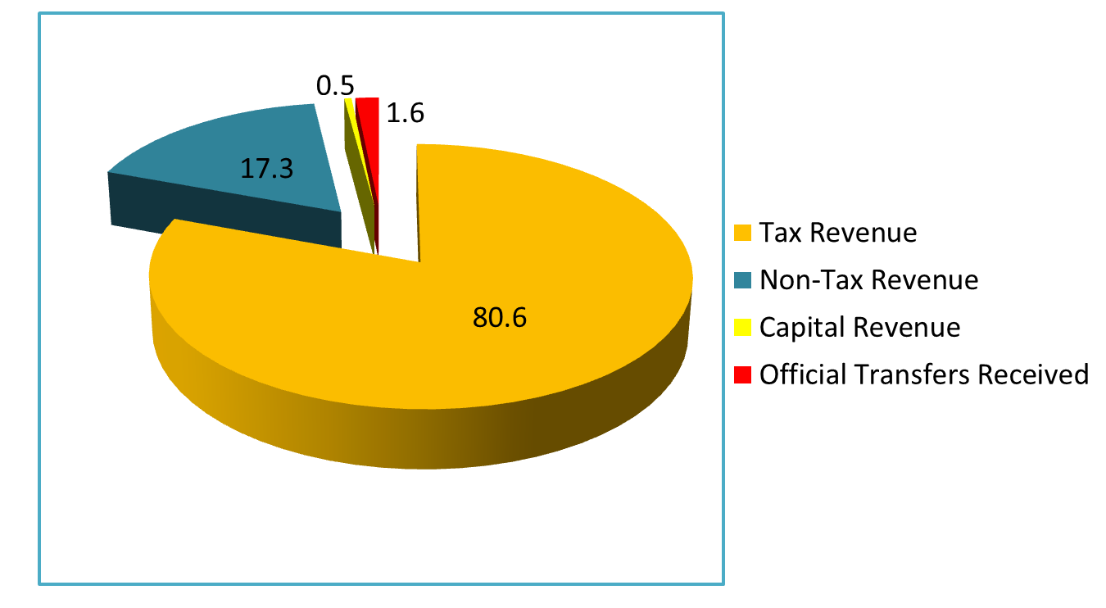

**Structure of Income in Percentages**

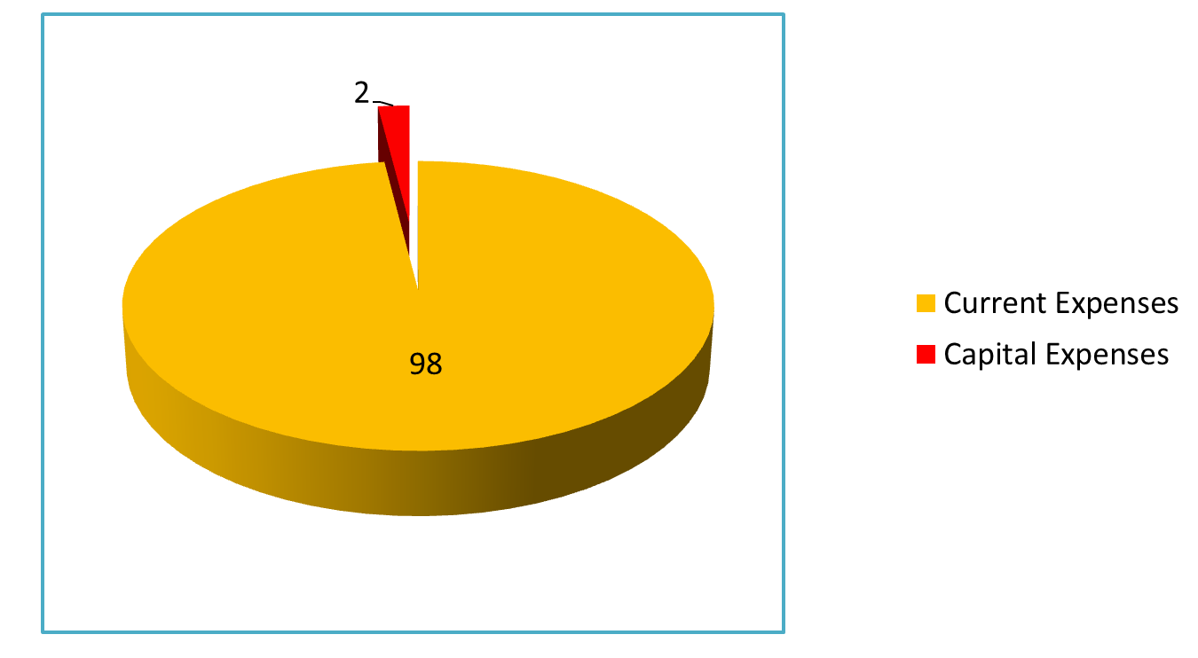

**Structure of Expenses in Percentages**

***State budget expenditure***

Government expenditure is the expenditure of the government to purchase goods and services for public consumption. Expenditures also divide into three main groups. There are current, capital and loans by the government.

Current expenditure includes most part of spending that is provision of public goods and services. Current expenditure constitutes 98% of all expenditures and the rest 2% is for capital expenditures. Capital expenditures relates to investing part of the government. Government spends part of state budget on investments that are aimed for future economic growth. And third part is loans by the government. It happens only in case if the government has surplus of budget, revenue exceeds the expenditures. Unfortunately, it is not the case of Kyrgyzstan, as last decade Kyrgyzstan has only deficit and should borrow in order to cover the budget deficit.

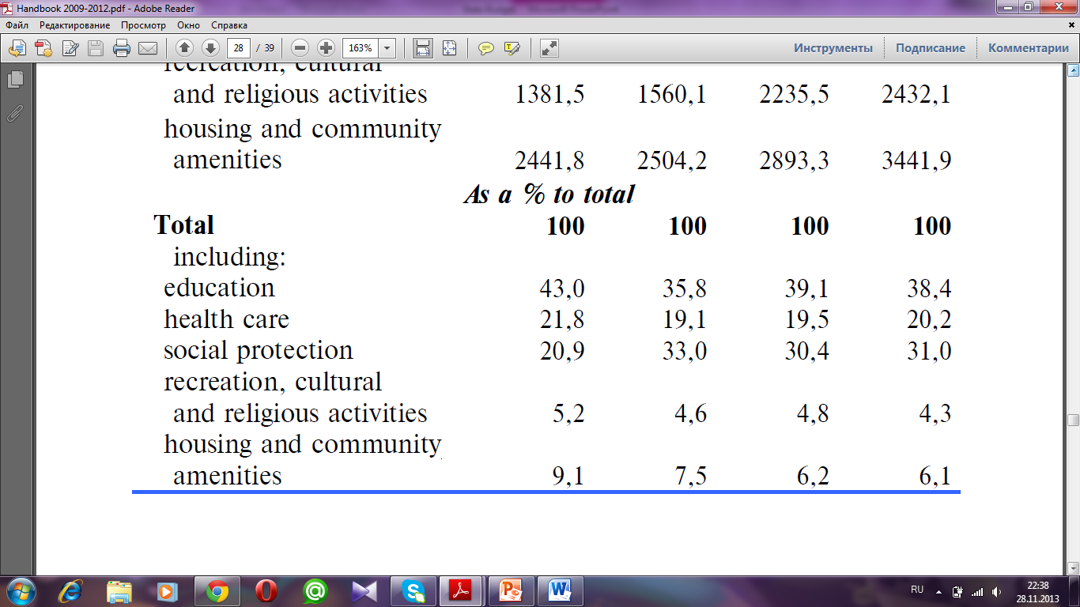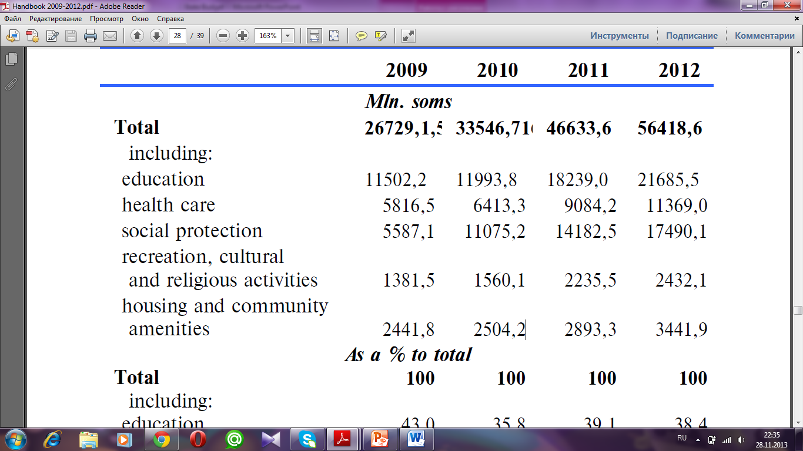

According to these chart there we can see the main parts of expenditures, expenditures on social life that includes key points such as expenditures on education, medical healthcare, social protection and others. As we can see the education among them takes the biggest part, 43% in 2009. And the share of expenditures on education decreases through the years but in absolute values it increases, due to increase of government revenue. Significant increase in education spending in absolute values were in 2011 and 2012, the reason for that could be that after political instability and dismissal of ex-president of Bakiev and appointment of new president Atambaev let for the country turn to another direction toward economic growth and development. Thus policies of new president were to increase the salary of teachers and medical workers, thus increasing the government expenditures.

***Proficit (surplus) and deficit***

At the end of each year a National Statics Committee reports the result of the government’s activities saying that whether we have “Deficit” or “Proficit” in our State Budget for a certain year. So when they say we have a deficit, they mean that our government expenditures exceed the government income, and vice-versa when there is a proficit of State Budget, it means that our income exceeds the expenditures.

For coping against the deficit to fulfill the shortage, the government has several instruments such as increasing the tax rates, increase capital income (selling government property, for instance bonds, securities and etc), loans and borrowings from other countries or from IMF and World Bank.

The government has to solve problem in case of proficit as well, because the money can lose its value if it is just kept under the pillow. Therefore it should be always in circulation. In this case the government can pay for the government debts, put into reserve fund, or lend to other countries.

**The following chart shows the income and expenditures of Kyrgyz Republic for 2008-2012 years.**

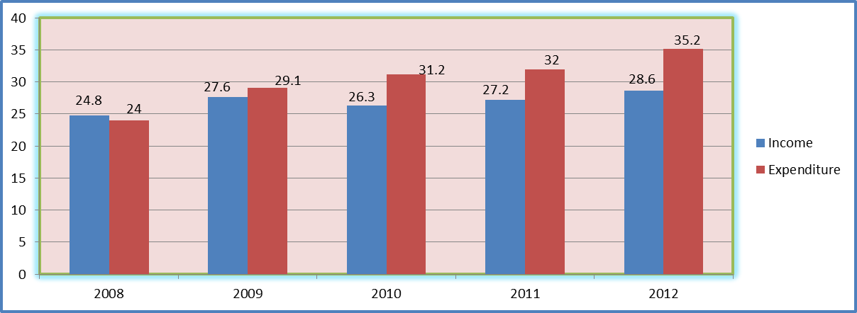

Unfortunately, as we can see from the chart, the tendency looks sad starting from the year of 2009, because the government could not cover its expenditures since 2008. We can explain such phenomena referring to the *World Economic Crisis* that started in 2008. As we know, 2008 was the year when Kyrgyzstan had succeeded to reach the level of economic growth of 1990 after 18 years later.

**This chart represents the Deficit (Proficit) of Kyrgyz Republic for years 2008-2012. The estimation is in percentages to the GDP.**

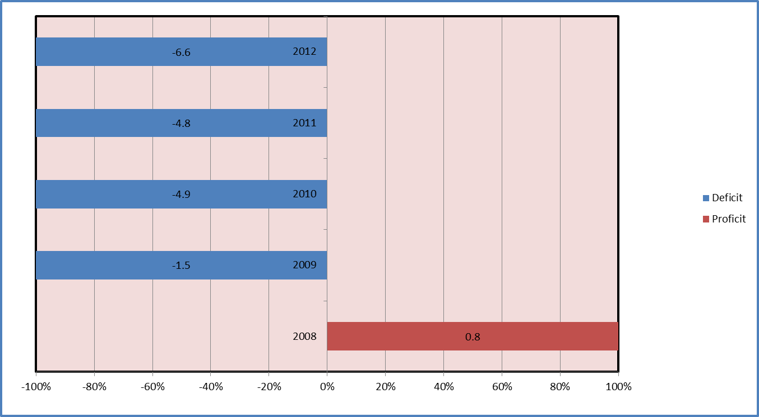

The peak of economic growth for Kyrgyzstan was the year of 2008, and then different external and internal circumstances such as the *World Crisis, and Political Instabilities* followed which led to the downturn of the economy. Year by year the percentage of *Budget Deficit* is increasing. The other factor such as *Human Resource (corruption)* can also serve as one of the key reason for such tendency in the economy.

***Government debt***

**The first table shows the Internal Sources of finance that Kyrgyzstan uses to cover the State Budget Deficit. All numbers are in percentages.**

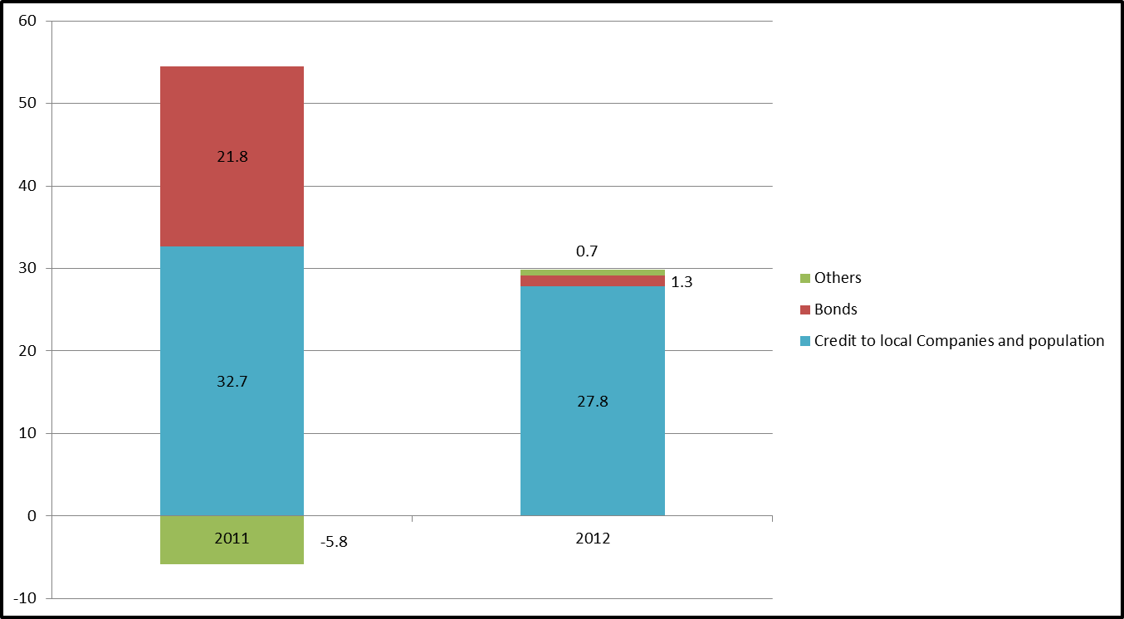

**The second graph shows the External Sources of finance that Kyrgyzstan uses to cover the State Budget Deficit. All numbers are in percentages**

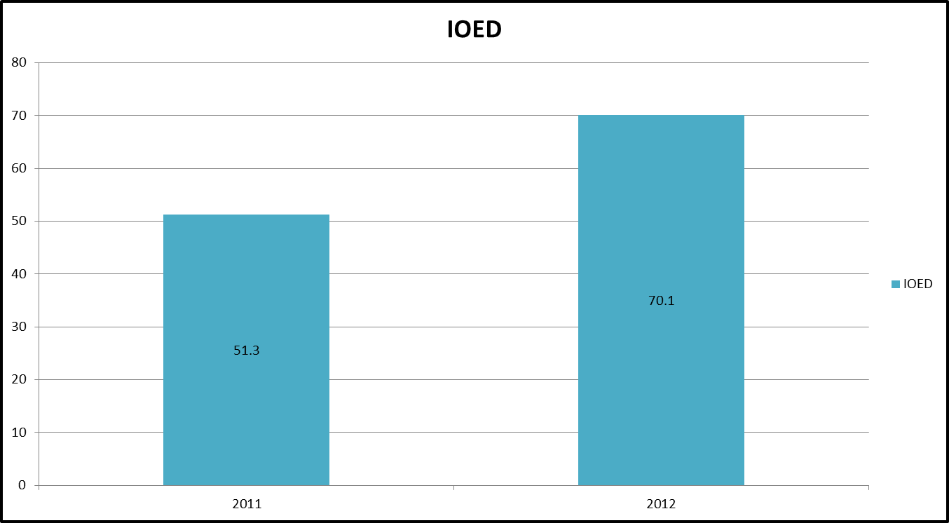**(IOED(International Organization of Economic Development))**

**The ratio between Internal and external Financing for 2011**

**The ratio between Internal and external Financing for 2011**

Kyrgyzstan has two sources from which it gets money to cover the hole in the economy. First one is internal source. It includes bonds, credits to businesses companies, financial organizations, and to the population. But it compounds only the 30% of financing. The other 70% of financing comes from abroad in terms of *Financial Aid or Borrowings* from other countries like Japan, Turkey, Germany, Russia, including *International Organization of Economic Development, International Mutual Fund, World Bank, ABD.*

All of the borrowings that the government received go to the government’s debt, which is the national debt of the country. Public debt is a debt to the country's legal and natural persons, foreign states, international organizations and other entities. So as a rule there are two types of national debts:

***External*** – the state debt expressed in foreign currency to other countries, international economic organizations, and others.

***Internal*** – the state’s debt expressed in national currency (som) to the holders of government securities (GS) and other creditors.

The Ministry of Finance of Kyrgyz Republic deals with implementation of the common policies in coping with government debt.

**The third chart shows the government debt of Kyrgyz Republic in proportion of external and internal debt.**

Government debt takes 50 percent of whole GDP. The overall government debt is $3.275 billion.

Kyrgyzstan borrowed money for 15-40 years with 0.5-2.5 interest rate. However we have cases when the lending part has written off the debts for Kyrgyzstan. For instance in 2002 Paris club had facilitated credit for Kyrgyzstan from 102 million in US dollars to 5,6 million in US dollars, Russia had written off 300 million US dollars, Turkey had written off 49,2 million US dollars. Unfortunately the government still continuing borrowing money from abroad, enhancing the amount of debt furthermore.

***Budget Transparency***

***“I think they just ate the funds. Do you see a school here?”* “**This was the response from a man from Likoni, a poverty ridden area on the outskirts of Mombasa, Kenya, when asked about what happened to over US$55,000 that the local government was supposed to have used to build the Mrima Secondary School”,(Open Budget Survey 2012). It is true for our country as well, because the citizens stop believing in any words and promises made by the government because of their infinite failures in developing the economy of Kyrgyzstan. We receive huge amount of financial aids from abroad for specific purposes like developing infrastructure, tourism and so forth. However we did not see any changes toward the high standard of living, and this all is happening because of the unaccountability and not transparency of the STATE BUDGET. The people Kyrgyzstan do not know what is happening to that tremendous sum of money that comes to Kyrgyzstan as an aid.

**The table below shows the transparency rate of State Budget of countries in OBI score.**

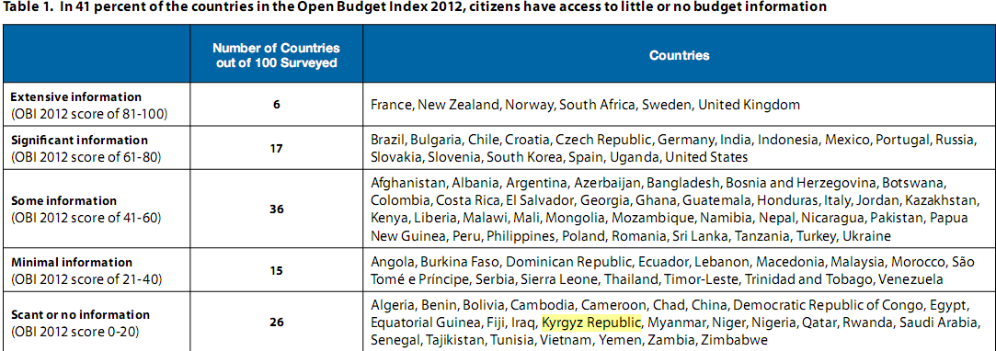

As you can see from the table, Kyrgyz Republic is in the list of countries that do not give any clear information about the financial activities of the government.

The research that was held in 2012 on **Budget Transparency** says that, transparency can help to attract cheaper international credit. Research commissioned by the IBP (International Budget Partnership) finds that, after control-ling for various economic variables, countries with higher levels of fiscal transparency have higher credit ratings and lower spreads between borrowing and lending rates, thus reducing governments’ borrowing costs. Even for countries with similar credit ratings, higher transparency is associated with lower spreads.

***Conclusion***

The state budget system of Kyrgyzstan seems to be not effective. So far Kyrgyz Republic had been receiving huge amount of financing in terms of loans and just aids from abroad (Russia, Germany, Japan and from International Organizations such as ABD, IMF, World Bank) for some economic activity. However we do not see the result at all. I want to cite one more the words of simple citizen of Mombasa, Kenya, ***“I think they just ate the funds. Do you see a school here?”***  On news through mass media people read and hear that Kyrgyzstan gets certain amount of money to build some buildings, repair roads, reconstruction of schools and bridges, development of tourism and so on. Unfortunately they do not see any changes, and they also cannot control them, because they cannot see what happened to those financial aids. Therefore in order to accelerate the economic growth without going in any debt, the country should first of all be transparent to the usual people, since the government actually is controlling over the resources that belong to the nation as a whole. Currently according to many researches, financial aids lead to the downturn of the economy. However, if the government uses these aids effectively, meaning without any smuggling, financial aids can have a positive effect on economic growth. For that, a government should make state budget transparent to all people, so that the people would know the financial activities of the government and keep track on preventing any corruptions among the politics. We believe that only in this way we can see some changes in the development of the economy and in the country as a whole.

***Literature Review***

* **“Budget Survey 2012”,** *“International Budget Deficit”,*2012
* **“Руководство по бюджету для граждан”,** 2007
* **“Расходы и Доходы Государственного Бюджета”,** stat.kg
* **“Государственный Долг Кыргызстана”**, vb.kg

***Appendix 1***

***Income of State Budget***

|  |  |  |  |  |  |
| --- | --- | --- | --- | --- | --- |
|  | 2008 | 2009 | 2010 | 2011 | 2012 |
| Official Transfers Received | ***1399763,1*** | ***10201145,8*** | ***7022062,1*** | ***8752288,2*** | ***5608258,6*** |
| Non-Tax income | ***8179699,3*** | ***9058446,6*** | ***11000234,4*** | ***15654627,8*** | ***17252409,8*** |
| Income of property and interests | 2756505,6 | 3289991,7 | 4894648,4 | 8141767,6 | 9032710,0 |
| Income from sales and Services | 4765423,7 | 5282704,0 | 5293671,8 | 6503909,3 | 7217118,9 |
| Administrative Payment | 841775,9 | 807150,7 | 662938,6 | 1023773,2 | 1128106,3 |
| Revenue from Services | 3923647,8 | 4475553,3 | 4630733,2 | 5480136,1 | 6089012,6 |
| Fines, Compensations, and Sanctions | 231843,8 | 317422,6 | 243581,9 | 335940,2 | 294748,2 |
| Voluntary Transfers, except Grants | 135889,9 | 54059,3 | 4495,4 | 8902,9 | 338716,0 |
| Other non-tax income | 290036,3 | 114269,0 | 563836,9 | 664107,8 | 369116,7 |
| Income from sales of non-financial assets | ***1116816,8*** | ***312072,8*** | ***628191,7*** | ***456105,6*** | ***236047,4*** |