**American University of Central Asia**

**M.Sc. in Economics Program | BA in Economics Program**

**Course syllabus, Spring 2022**

**Intro to STATA**

|  |  |
| --- | --- |
| **Instructor:** Akylai Muktarbek kyzy  **Credit points:** 3 | **Office hours:** by appointment  **Email:** muktarbek_a@auca.kg |

**Course Description/Overview**

This is an introductory course to STATA for students with no or limited experience with this software. It is aimed to teach students about the basic functionality of STATA and how it can be used to analyse different data sets and in applied research. It is a project-based and practical course.

The course will introduce students to the principles of carrying out statistical analysis. They will learn how to enter and manipulate data, and run regressions and prepare statistical tests. This is a graduate-level course (distance-learning) for students in social sciences. The course will consist of readings and presentations, practical exercises, and individual projects.

**Learning Outcomes/Objectives**

This course will be designed to enable students to meet the following final terminal learning objectives:

• being familiar with the STATA interface

• data entry/loading, using do files and log files

• data manipulation

• summarise descriptive statistics

• produce and edit graphical displays

• perform basic parametric tests

• perform non-parametric tests

Students are expected to familiarize themselves with the assigned topic and readings each week and should be prepared to participate to discuss the topics critically.

**Course Requirements**

Class participation is both important and required. Students are expected to complete and submit all course assignments on the dates scheduled. All assignments should be submitted through **e-course** on the due day. Assignments submitted by email or in person will not be accepted.

Students should contact the instructor if there are any questions about the direction or content of the assignments, or if they wish feedback on class performance.

Students are expected to install STATA to their computers before coming to class. In case they struggle with doing so, they are recommended to work in AUCA labs, where STATA software is available.

**Evaluation and Grading**

Class participation and attendance 10%

Assignments (3 out of 4) 30%

Mid-way assessment 30%

Final project 30%

The detailed evaluation rubric for each assignment will be provided separately.

Standard AUCA Grading system will be applied:

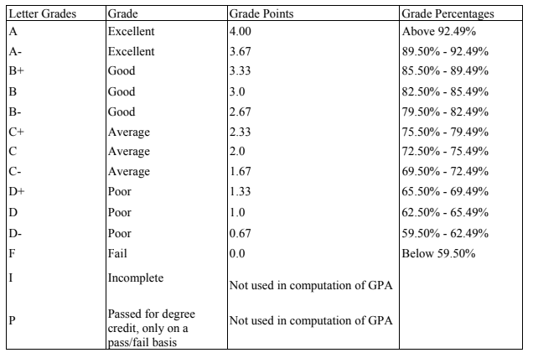

**Sources:**

stata.com/links/resources-for-learning-stata

**Course content and schedule**

|  |  |  |
| --- | --- | --- |
|  | Topics | Students Assignments |
| 1 | Introduction (Why Stata? Course structure)  Getting started  • interface  • using help effectively  • command syntax  • .do and log files  Data entry and loading  • Importing data | • Forum 1: Introduction |
| 2 | Exploring data  • Viewing raw data  • describing and summarizing  • tabulating and tables  • missing values  • weights | • Practice exercise |
| 3 | Manipulating data  • Recoding an existing variable  • Generating a new variable  • naming and labelling variables  • extended generate (egen command)  • keeping and dropping variables | • Assignment 1: exploring data |
| 4 | Manipulating data, part 2   * Merging and appending * Local macros and looping * Repeating commands by looping over variables and numbers * Accessing results save from Stata commands | • Assignment 2: Manipulating data |
| 6 | Graphing in Stata  • graph command  • bar graphs and dot charts  • distributional analysis (graphical)  • pie charts  • Scatterplots and fitted lines | • practice exercise |
| 7 | Graphing in Stata, part 2  • controlling legends  • adding text and textboxes  • combining graphs  • more on visualization techniques | • MID-WAY ASSESSMENT |
| 8 | Basic inferential statistics  • statistics of two categorical variables  • tests for one or two means  • bivariate correlation and regression  • analysis of variance | • practice exercise |
| 9 | Ordinary least squares (OLS) regression  • OLS regression and interpretation in Stata  • Categorical explanatory variables in OLS  • Interaction terms in OLS | • Assignment 3: OLS |
| 11 | OLS regression, part 2  • OLS regression diagnostics  • OLS hypothesis testing  • Presenting OLS regression estimates | Practice exercise |
| 12 | Binary outcome models (logit and probit)  • linear probability, logit, and probit models  • diagnostics  • interpretation of coefficients and margins | Assignment 4: Binary outcome models |
| 13 | Categorical choice models  • ordered logit and ordered probit  • multinomial logit | Practice exercise |
| 14 | Panel data modeling  • setting up panel data  • panel data descriptives  • linear panel estimators  • random or fixed effects  • the Hausman test demo | Drafting final project |
| 15 | Working on final projects | Final project uploaded |