# E-tivity: Do a resource audit

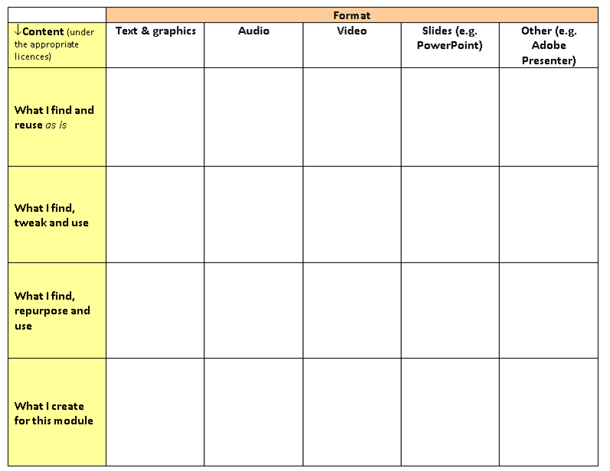

## Purpose

To decide how you will source the content for your module/course, including the possibility of incorporating OERs produced elsewhere.

## Task

1. Working with your team members, open the [Learning Design Resource Audit](http://www2.le.ac.uk/projects/oer/oers/beyond-distance-research-alliance/7cs-workshop-resources/Carpe%20Diem%20Resource%20Audit.docx/view) (opens as a Word Document). The second page of the document contains an example of a semi-completed resource audit.
2. Brainstorm your ideas for gathering or creating content for your course.
3. Once you have filled in your Resource Audit, please upload it to the relevant page in the Wiki for your module/course.

## Response/ discussion

When you have finished, look at the Resource Audit of other groups to see how theirs compare to yours, and share your feedback via the Comments facility in the Wiki.

## Timing

Approximately, 60 minutes, including post e-tivity discussion.

## Participation link

[Trainer/ facilitator to add link to wiki.]

|  |
| --- |
| Additional resources/ references/ tools If you haven’t already done an OER search, spend some time looking for suitable OERs to fill any content gaps. You will find links to OER repositories and excellent advice on searching for OERs from the [Commonwealth of Learning](http://col-oer.weebly.com/module-4---the-oer-landscape---how-to-find-oer.html) and the [JISC OER Infokit](https://openeducationalresources.pbworks.com/w/page/27045418/Finding%20OERs). You can also search for OERs using Google Advanced Search, and specifying "Free to use share or modify" in the Usage Rights filter. |

|  |
| --- |
| About this resourceThis resource is part of the 7Cs of Learning Design toolkit. For details on how to use it, please go to [link]. Attribution and licence: This work by [Beyond Distance Research Alliance](http://www.le.ac.uk/oer) is licensed under a [Creative Commons Attribution 3.0 Unported License](http://creativecommons.org/licenses/by/3.0/). Permissions beyond the scope of this license may be available at<http://www.le.ac.uk/beyonddistance>.    Date modified: 5 Jan 2013  Description of changes made: Formatting (G. Witthaus)  URL: <http://goo.gl/C31yv> |

This 7Cs e-tivity template by the Insitute of Learning Innovation at the University of Leicester (2013) is available under a CC-BY licence at <http://goo.gl/BqKX0>.