Christianity in Central Asia:

The Question of Nestorianism

**Documents**

Dr. Sam Thomas

World History 9

University School

Name: ___________________________________

Document A: *Berkshire Encyclopedia of China*

Christianity was introduced to China during the Tang dynasty (618-907) and became widely known as “Jingjiao” (Luminous Teaching) during the Tianqui period (1625-1627) of the Ming dynasty (1368-1644) after the discovery of a luminous stele (a stone pillar used for commemorative purposes). Modern scholars identify this form of Christianity as Nestorianism, one of the churches of the East led by Nestorius (386-451). Nestorius was banished in 431 for his heretical views regarding Jesus as both a man and a divine son.

Persecution for heresy forced the Nestorians toward Central and East Asia, including China…The most important historical sources have been the Nestorian Stele, five Nestorian manuscripts written in Chinese, and numerous tomb inscriptions found in Inner Mongolia and Quanzhou.

According to these sources, Nestorianism was introduced in China by Alopen in 635. At that time, acting under an imperial edict, the Nestorians first translated their scriptures into Chinese and established a church at Chang’an. After that, many Nestorians came to China either by land from Central Asia or by sea from Persia (Iran). The Nestorian stele was erected in 781, a time of relative prosperity for Chinese Nestorianism.

However, after 845 the Nestorians virtually disappeared in Chinese sources, having suffered political persecution. They fled from central China and settled in peripheral regions, especially Samarquand and Turfan. Tomb inscriptions show that Nestorianism experienced a modest revival in several regions during the Yuan dynasty (1279-1368) especially in Inner Mongolia. [The Yuan dynasty was founded by Kublai Khan, a grandson of Genghis Khan.]

Source: “Nestorianism.” *Berkshire Encyclopedia of China*. Great Barrington, MA: Berkshire Publishing Group, 2009.



Document B: Map

Document C: Nestorian Stele

*In the early 17th Century near the city of Chang’an, Christian missionaries discovered a stone stele (monument) explaining Christian doctrine and the early history of the Chinese church. The stele has been dated to 781.*

Thus, one of the Trinity the Messiah of the Christians, concealing his true divinity came into the world as a man. Angels declared his coming, and the Virgin gave birth to the Holy one in **Da Qin**.[1] Seeing the splendor of a bright star indicating this auspicious moment, the Persians brought their tribute to the Holy One.

Having fulfilled the traditional laws set by twenty-four early saints, He made a great plan for families and states. He set up a new doctrine of the pure and silent spirit of the Trinity, using the right faith to cultivate morality…

In the country of Da Qin there was a great priest whose name was Raban. He carried the true scriptures and suffered extreme hardship to make his way to China and he reached the city of Chang’an in [645]…The Emperor came to a deep understanding of the true teachings of Christianity and gave an order that it should be taught in the realm. He issued an edict saying:

“There can be more than one name for the Way along which the sacred path runs; there can also be different ways to express sacredness. The Archbishop Raban traveled a great distance from Da Qin in order to present the scripture and images of the saints to my court. After learning from its doctrine, I feel the religion is beautiful, mystic, and peaceful. Its basic doctrine provides the essential teachings and there are no redundant words and all are pure truth. It is helpful to all the people and therefore should be spread to all the lands under the heaven.”

Source: Liu, Xinru. *The Silk Roads: A Brief History with Documents*. The Bedford Series in History and Culture. Boston: Bedford/St.Martins, 2012.

Document D: Jesus-Messiah-Sutra

*This document is the oldest of four Nestorian ‘gospels’ discovered in 1908. It was probably written around 635.*

The Lord of Heaven incessantly going around all over the world, is constantly present everywhere.

The person of the Lord of Heaven is in brightness, joyous and peaceful, and swells in Heaven in comfort.

All the Buddhas wander here and there by virtue of this very wind, while in this world. There is no place where the wind does not reach.

Man, therefore, in extremity, will always do honor to the name of Buddha.

The Lord of Heaven, however, gives man mind and wisdom not a little.

Therefore, whoever wants to return for the charity-favor of Buddha should have a clear understanding of his own sins and wicked deeds.

If he does, he will obtain heaven, even though he may not be well versed in the teaching.

….

The Lord of Heaven therefore made **“the Cool Wind”** enter a virgin named **Mo-yen**.[2]

Hereupon, the Cool Wind entered the body of Mo-Yen in accordance with the instruction of the Lord of Heaven. Suddenly Mo-yen became pregnant. After her conception, Mo-yen gave birth to a son named I-Shu, whose father was the Cool Wind.

And when I-shu was born, all the people of the world saw bright signs in heaven and on earth.

When the Messiah got as many as the twelve disciples he proceeded to endure suffering.

[I-shu is betrayed to a great king called Pi-lo-tu-ssu (Pilate) and sentenced to death.]

They bound Him upon the tree between two highwaymen, one being on the right and the other on the left. It was at dawn that they bound Him upon the tree but by the time the sun came toward the west there was black darkness on every side and the earth quaked and the mountains were rent, and all the gates of the graves were opened and the men got life

[The document ends shortly after without any discussion of I-shu’s ultimate fate.]

Source: Saeki, P.Y. “The Hsu-T’ing Mi-Shi-So Sutra Or, Jesus-Messiah-Sutra.” *Journal of the North China Branch of the Royal Asiatic Society* 63 (1932): 31–45.

Document E: William of Rubruck (I)

*A Flemish Franciscan monk, William of Rubruck (Willem van Ruysbroeck, ca. 1210-ca. 1270) wrote the most detailed and valuable of the early Western accounts of the Mongols. William had participated in the crusade of King Louis IX of France to Palestine and there heard about the Mongols. In 1253 he set out through the lands of the western part of their empire (what we know as the Golden Horde)--that is starting out through the southern steppes of what is now Ukraine and Russia.*

*His journey lasted the better part of three years. William had the distinction of being the first European to visit the Mongol capital of Karakorum on the Orhon River and return to write about it. He provides a unique description of the Khan's palace there and abundant detail about the individuals of various ethnicities and religions whom he encountered. Understandably, he was particularly interested in the Nestorian Christians. His describes generally with great precision Mongol traditional culture, many features of which have survived amongst the herders one may observe today in inner Asia.*

There are Nestorians in fifteen cities of Cathay and they have a bishopric there in the city called **Segin**,[3] but beyond that they are pure pagans. The pagan priests these people all wear wide **saffron-colored cowls**.[4] There are also among them certain hermits who live in forests and mountains and who are wonderful by their lives and austerity.

The Nestorians there know nothing. They say their offices, and have sacred books in Syriac, a language of which they are ignorant, so they chant like those monks among us who do not know grammar, and they are absolutely depraved. In the first place they are usurers and drunkards, and some of them who live with the Tartars have several wives like them. When they enter a church, they wash their lower parts like Saracens; they eat meat on Friday, and have their feasts on that day in Saracen fashion.

The bishop rarely visits these parts, hardly once in fifty years. When he does, they have all the male children, even those in the cradle, ordained priests, so nearly all the males among them are priests. Then they marry, which is clearly against the statutes of the Fathers, and they are bigamists, for when the first wife dies these priests take another. They are all simoniacs, for they administer no sacrament without payment.

Sources:

<https://depts.washington.edu/silkroad/texts/rubruck.html> and Dawson, Christopher, ed. *The Mongol Mission: Narratives and Letters of the Franciscan Missionaries in Mongolia and China in the Thirteenth and Fourteenth Centuries*. New York: Sheed and Ward, 1955.

Document F: William of Rubruck (II)

Then came the grand secretary, who was a Nestorian Christian, and whose advice they nearly always follow, to look at us: and he examined us carefully. Then we were told to go back to our lodgings; and, as we were going back, I saw before the east end of the **ordu**,[5] the distance of two crossbow shots from it, a dwelling with a little cross over it.

Greatly pleased, and imagining there was something Christian there, I boldly went in, and found an altar right beautifully decked. For there was embroidered on a cloth of gold an image of the Savior, of the Blessed Virgin, of John the Baptist and of two angels, and the lines of the body and of the garments were marked out with pearls, and there was a great silver cross with gems in the angles and the middle, and many, other church ornaments, and an oil lamp having eight lights was burning before the altar; and there was seated there an **Hermenian monk**,[6] swarthy and lank, and he was dressed in a tunic of the roughest hair-cloth reaching halfway down to his shins, and over it he had a stole of black silk lined with vaire, and under his hair-cloth garment he wore an iron girdle.

As soon as we entered, and even before saluting the monk, we sang on our knees: *"Ave regina coelorum,"* and he arose and prayed with us. Then, having saluted him, we sat down beside him, and he had a dish with some fire in it before him. We told him the cause of our coming, and he began encouraging us greatly, telling us to speak boldly, for we were the envoys of God, who is greater than any man.

Source:

https://depts.washington.edu/silkroad/texts/rubruck.html#court_christians

Document G: John of Monte Corvino

*Like William of Rubruck, John of Monte Corvino (1247-1328) was a Franciscan monk who travelled into east Asia. His journey came some years after William’s and his impression of the Nestorians was quite different in some ways.*

The Nestorians, who call themselves Christians, but behave in a very unchristian manner, have grown so strong in these parts that they did not allow any Christian of another rite to have any place of worship, however small, nor to preach any doctrine but their own. For these lands have never been reached by any apostle or disciple of the apostles and so the aforesaid Nestorians both directly and by the bribery of others have brought most grievous persecutions upon me, declaring that I was not sent by the Lord Pope, but that I was a spy, a magician, and deceiver of men.

And after some time they produced more false witnesses, saying that another messenger had been sent with a great treasure to the Emperor and that I had murdered him in India and made away with his gifts. And this intrigue lasted about five years, so that I was often brought to judgment, and in danger of a shameful death. But at last, by God’s ordering, the Emperor came to know my innocence and the nature of my accusers, by the confession of some of them, and he sent them into exile with their wives and children.

Source: Dawson, Christopher, ed. *The Mongol Mission: Narratives and Letters of the Franciscan Missionaries in Mongolia and China in the Thirteenth and Fourteenth Centuries*. New York: Sheed and Ward, 1955.

Document H: Nestorian Grave Markers (13th-14th centuries)

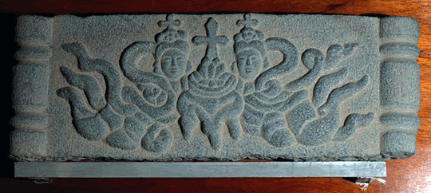

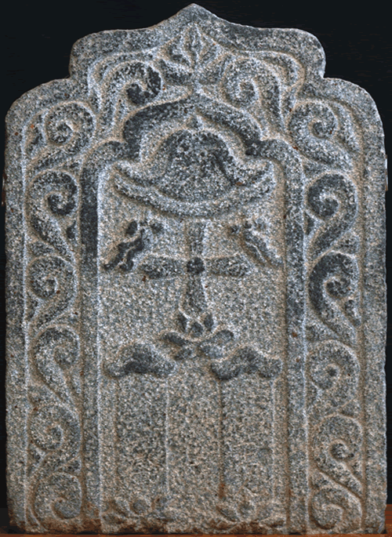Note the religious symbols seen here:

* The crosses representing Christianity
* The Lotus Flowers (beneath the crosses)
* The lotus is one of the key symbols of Hinduism and Buddhism, representing creation, renewal, and purity.
* The Buddha is often portrayed sitting on (or emerging from) a lotus flower.
* According to the Hindu text *Bhagavad Gita*, “One who performs his duty without attachment, surrendering the results unto the Supreme Lord, is unaffected by sinful action, as the lotus is untouched by water.”
* The two figures in the top stone are dressed in flowing draperies with billowing scarves and trailing ribbons are reminiscent of *Apsaras* or flying attendants in Buddhist iconography.
* The canopy above the cross in the second stone is often found in representations of the Buddha.

Top: <http://usf.usfca.edu/ricci/events/lotusandcross/lotusandcross19.htm>

Bottom: <http://usf.usfca.edu/ricci/events/lotusandcross/lotusandcross25.htm>

Document I: Rabban Sauma in Rome

*In 1287-88, a Nestorian monk named Rabban Sauma travelled to Europe, in hope of negotiating an alliance between the Mongols and Christian kings against the Mamluk Dynasty, which held Jerusalem and the rest of the Holy Land. The following excerpt is from his account of meeting leaders of the Catholic Church in Rome.*

RABBAN SAWMA said unto [the Cardinals], “Know ye, O our Fathers, that many of our Fathers have gone into the countries of the Mongols, and Turks, and Chinese and have taught them the Gospel, and at the present time there are many Mongols who are Christians. For many of the sons of the Mongol kings and queens have been baptized and confess Christ. And they have established churches in their military camps, and they pay honor to the Christians, and there are among them many who are believers. Now the king [of the Mongols], who is joined in the bond of friendship with the **Catholicus**,[7] hath the desire to take PALESTINE, and the countries of SYRIA, and he demands from you help in order to take JERUSALEM. He hath chosen me and hath sent me to you because, being a Christian, my word will be believed by you.”

Source: https://depts.washington.edu/silkroad/texts/sauma.html

1. Da Qin is the Chinese term for the Roman Empire, though it also applied to the Byzantines.
2. “Cool Wind” refers to the Holy Spirit; Mo-Yen is Mary.
3. Hsi-king, probably modern Beijing
4. Saffron robes are typically associated with Buddhist monks.
5. Camp.
6. Armenain?
7. Leader of the Nestorian Christians.