TYPES OF CAMERA SHOTS — THE SHOT SIZE

Camera Shot Size Summary
How you choose to frame your subject will have a specific impact. How close or far your subject is to your camera — your shot size — will underscore how the audience should feel about it (or them).
Your subject will appear smallest in a long shot (or wide shot). They will be larger in a medium shot and largest in a close-up shot.

Extreme Long Shot (ELS) or Extreme Wide Shot (EWS)
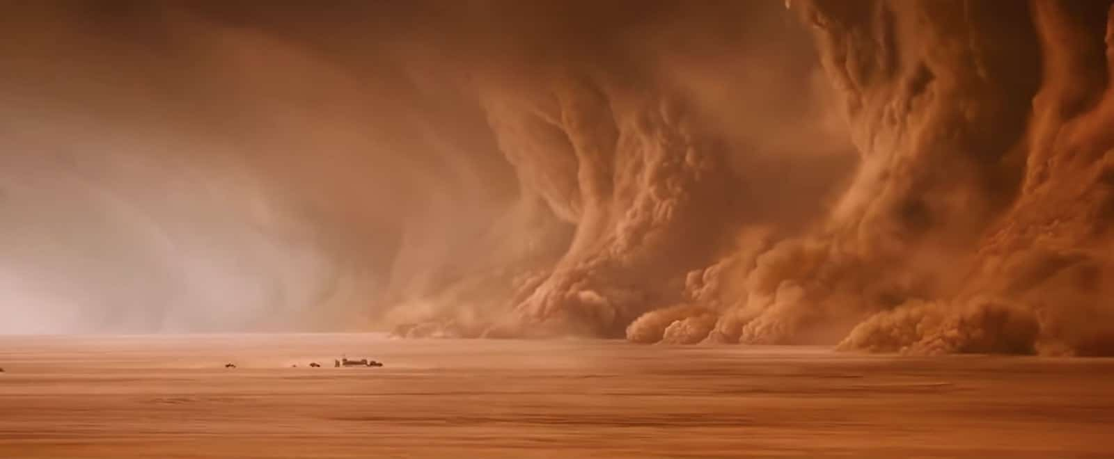

(EWS) Extreme Wide Shot Example in Mad Max: Fury Road
It can also make your subject feel overwhelmed by its location. Of all the various camera shots out there, consider using the extreme long shot when you need to emphasize the location or isolation.

TYPES OF SHOT SIZES

Long Shot (LS) or Wide Shot (WS)
The long shot (also known as a wide shot, abbreviated “WS”) is the same idea, but a bit closer. If your subject is a person then his or her whole body will be in view — but not filling the shot.
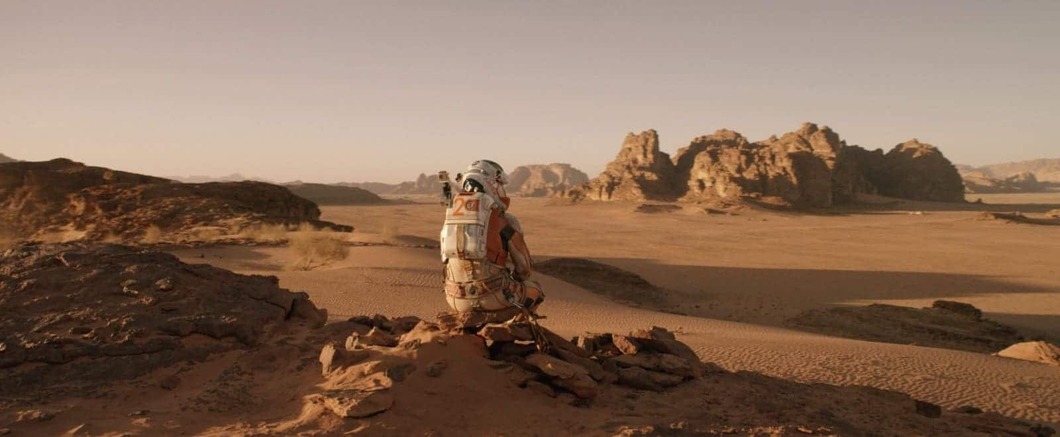

(WS) Wide Shot Example in
In other words, there should be a good deal of space above and below your subject. Use a long shot (or wide shot) to keep your subject in plain view amidst grander surroundings.
The wide shot also lets us see the beautiful background imagery, as well as the on lookers which will make any big moment more cinematic.
Of the many camera shots, a long shot gives us a better idea of the scene setting, and gives us a better idea of how the character fits into the area.

Full Shot (FS)
Now let's talk about camera shots that let your subject fill the frame while keeping emphasis on scenery.
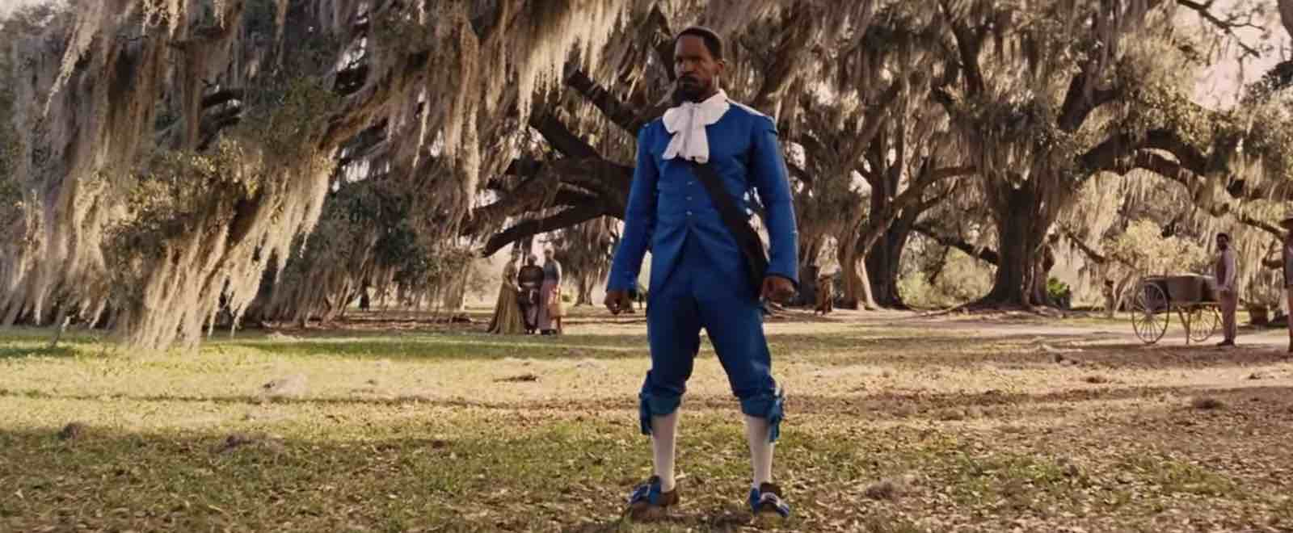

(FS) Full Shot Example in
Of all the different types of camera shots in film, full shots can be used to feature many characters in a single shot, like this full shot size example from Marvel's
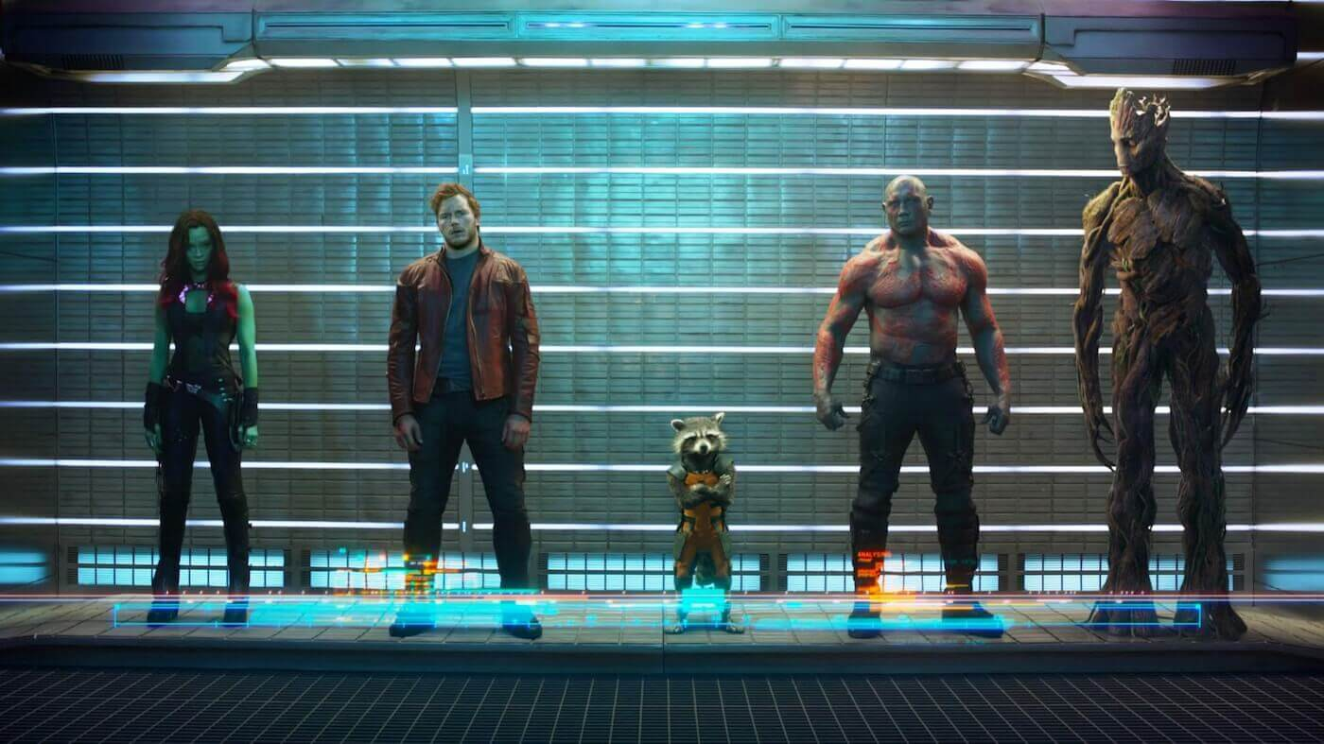

(FS) Full Shot Example in Guardians of the Galaxy

Medium Wide (or Medium Full) Shot (MWS)
A medium Full shot (medium long shot) frames the subject from the knees up. It splits the difference between a full shot and a medium shot.
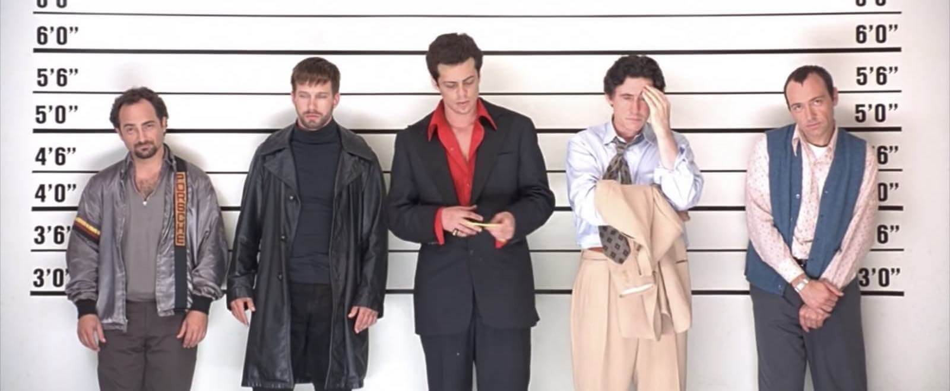

(MWS) Medium Wide Camera Shot Example
You can always frame camera shots from any angle as well, so don't be afraid to think about medium long shots when behind a character.

Cowboy Shot (CS)
A variation on this is the Cowboy Shot, which frames the subject from mid-thighs up. It’s called a “cowboy shot” because it is used in Westerns to frame a gunslinger’s gun or holster on his hip.
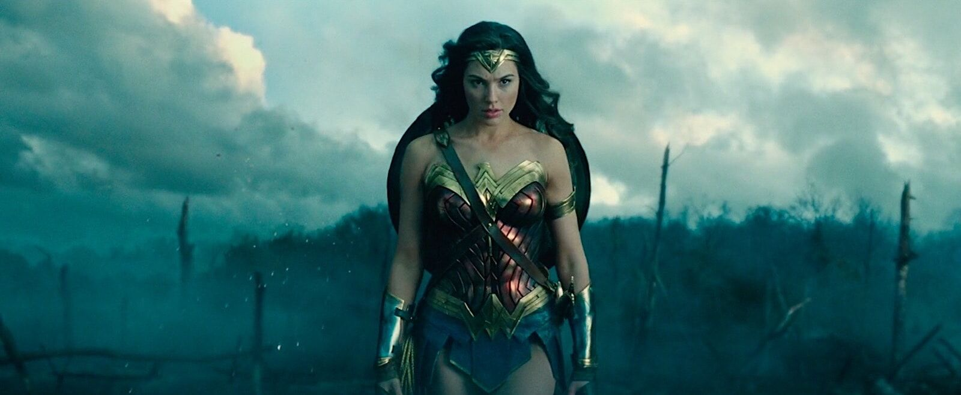

(CS) Cowboy Shot Camera Shot
Here is an example of a cowboy shot that's used in a film that has nothing to do with cowboys, and it's also a "three shot":
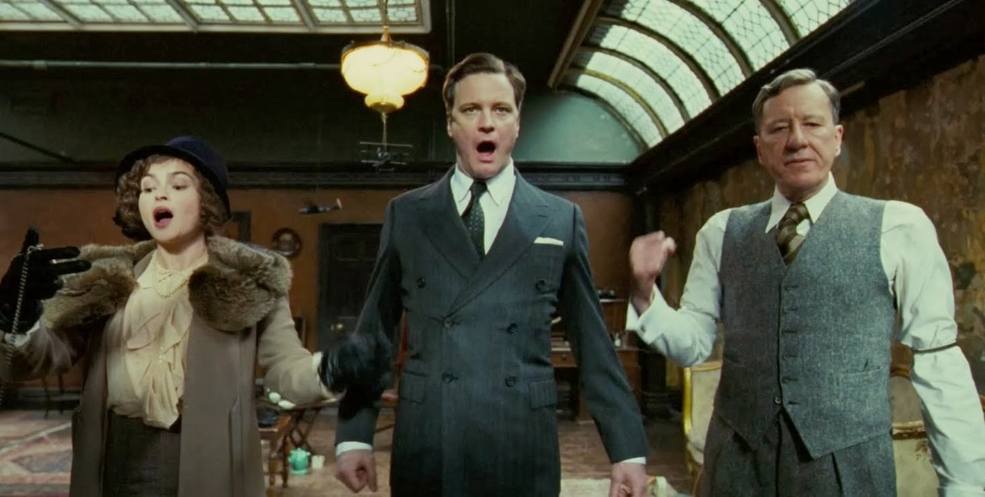

(CS) Cowboy Shot Example

Medium Shot (MS)
Let's move onto camera shots that reveal your subject in more detail.
The medium shot is one of the most common camera shots. It's similar to the cowboy shot above, but frames from roughly the waist up and through the torso. So it emphasizes more of your subject while keeping their surroundings visible.
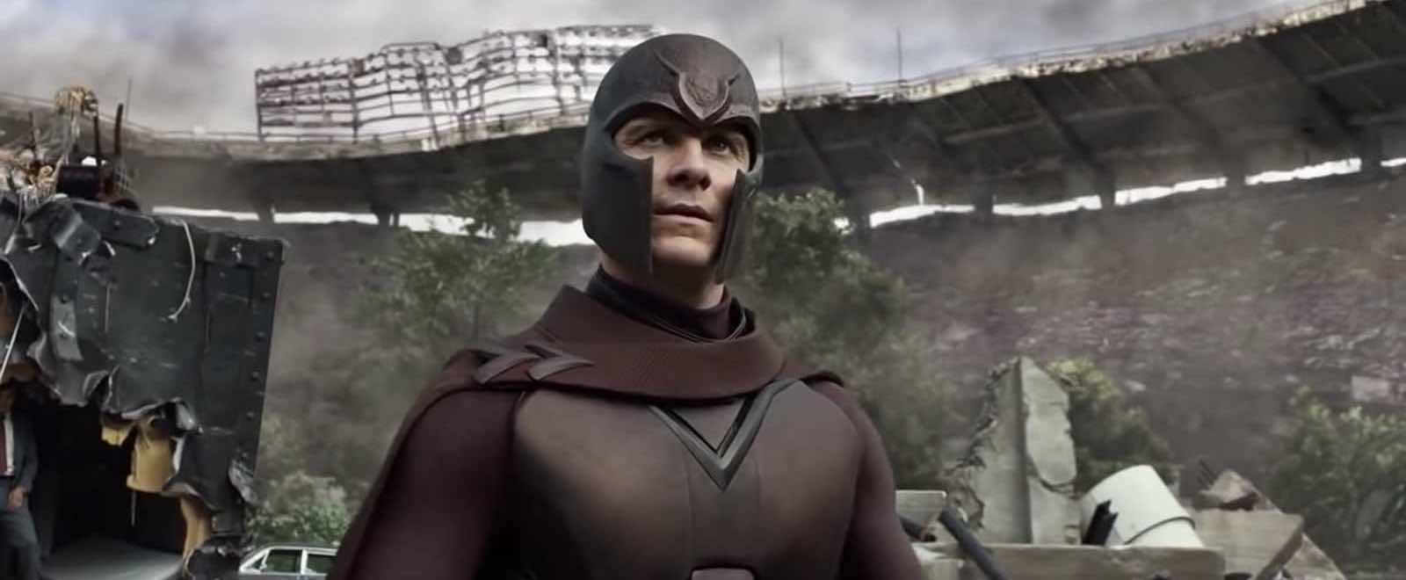

(MS) Medium Shot Example
Medium shots may seem like the most standard camera shot around, but every shot size you choose will have an effect on the viewer. A medium shot can often be used as a buffer shot for dialogue scenes that have an important moment.

Medium Close Up Shot (MCU)
The medium close-up frames your subject from roughly the chest up. So it typically favors the face, but still keeps the subject somewhat distant.
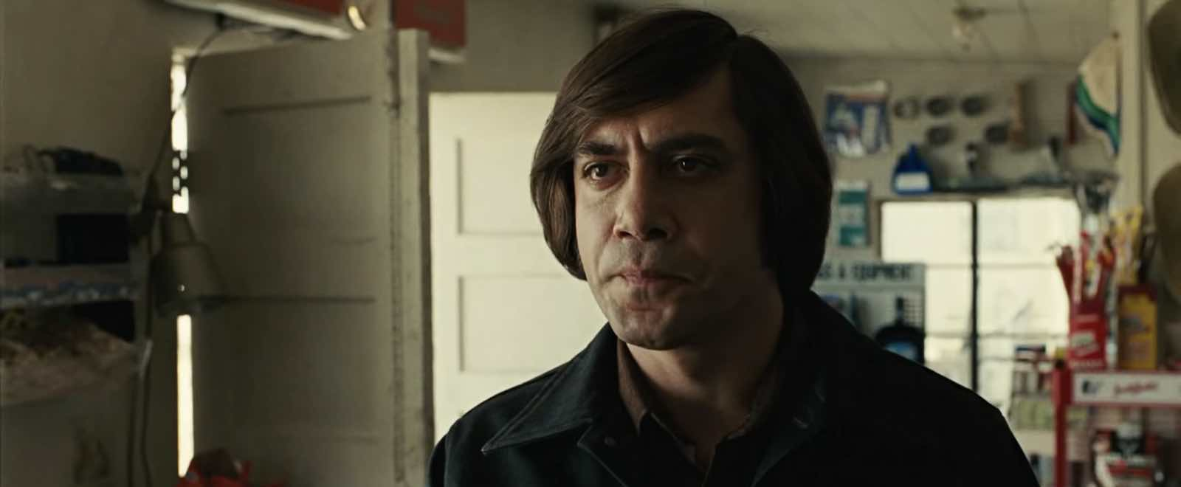

(MCU) Medium Close Up Shot Example
The medium close-up camera shot size keeps the characters eerily distant even during their face-to-face conversation.

Close Up (CU)
You know it’s time for a close-up shot when you want to reveal a subject’s emotions and reactions. The close-up camera shot fills your frame with a part of your subject. If your subject is a person, it is often their face.
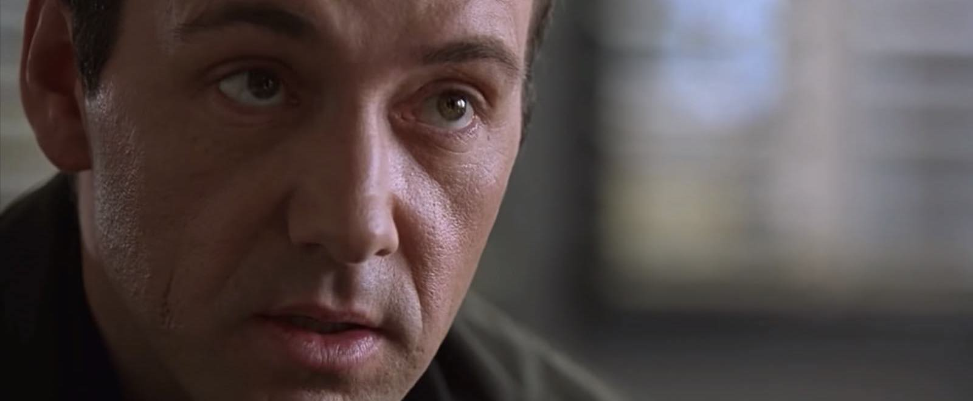

(CU) Close-Up Shot Example
Of all the different types of camera shot sizes in film, a close-up is perfect for important moments. The close-up shot size is near enough to register tiny emotions, but not so close that we lose visibility.

Extreme Close Up (ECU)
An extreme close-up is the most you can fill a frame with your subject. It often shows eyes, mouth and gun triggers. In extreme close-up shots, smaller objects get great detail and are the focal point.
Use an ECU to emphasize a specific feature of your subject:
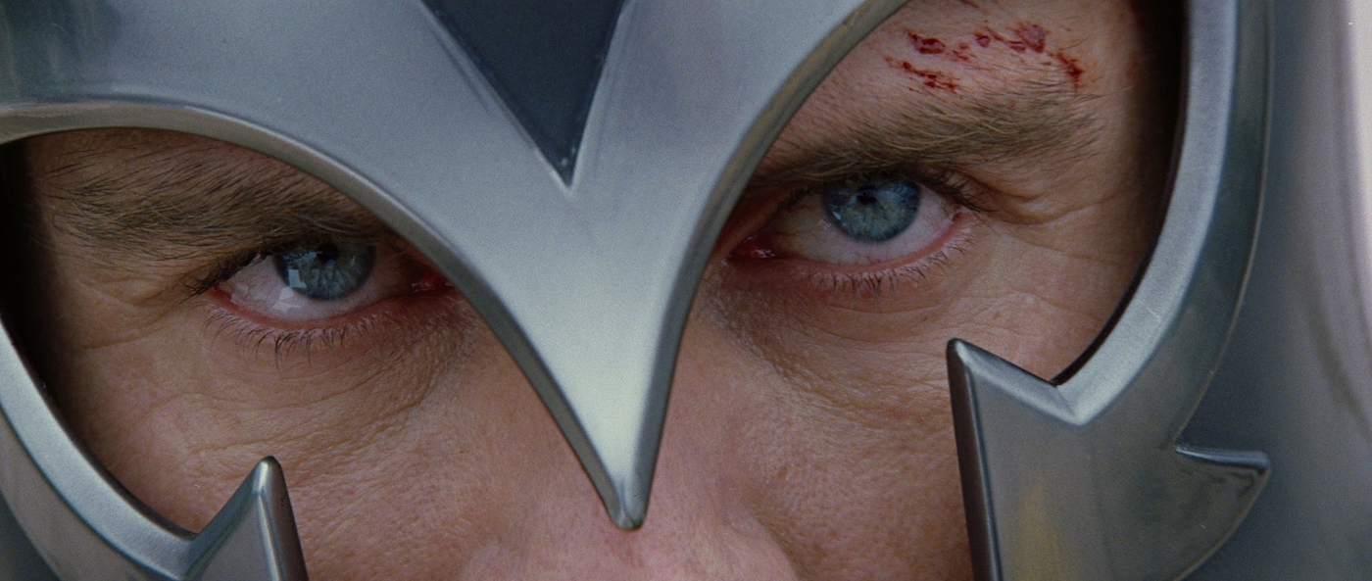

(ECU) Extreme Close-Up Camera Shot Example
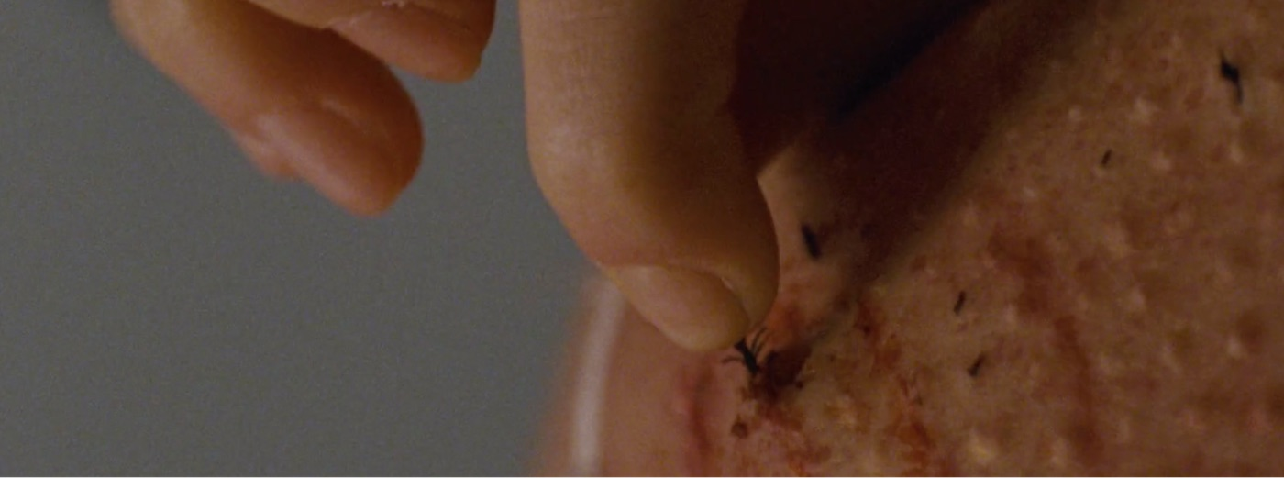

(ECU) Extreme Close-Up Example
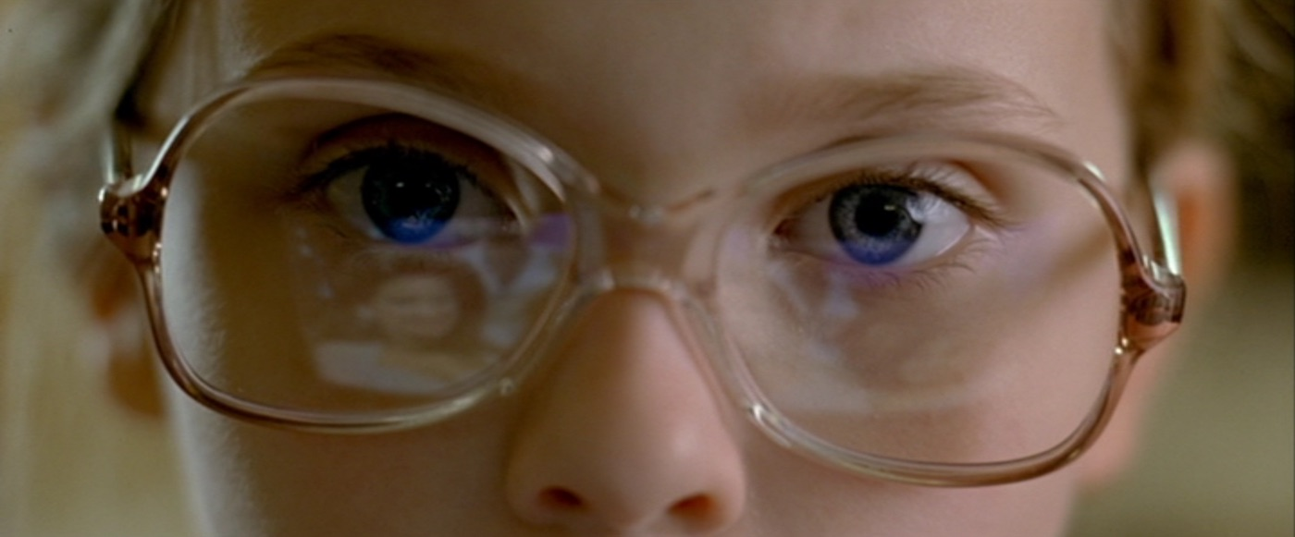

(ECU) Extreme Close Up

